**ECE-3502 IoT Domain Analyst LAB(L9+L10)**

**Name: Alpanshu Kataria**

**Reg. No.: 18BCE1267**

**Faculty: Prof. Maheshwari R**

Lab 8

**Task:**

Knime sales analysis

**Solution screenshots:**

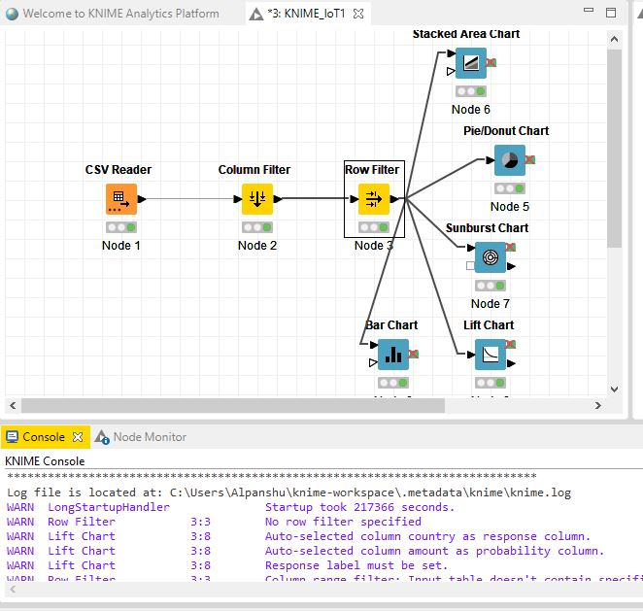

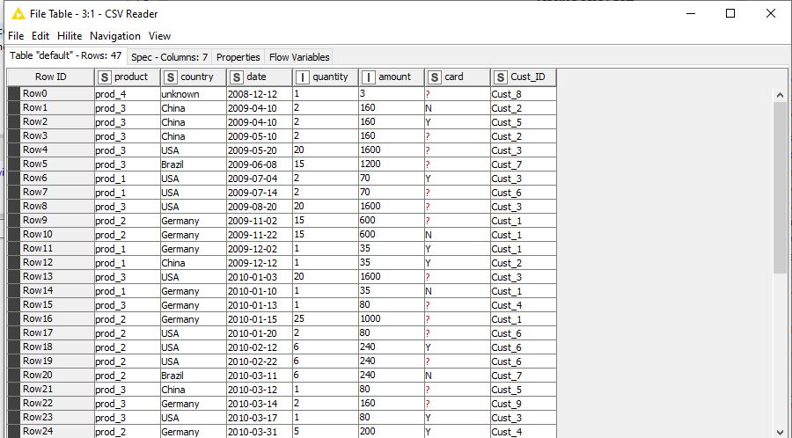**Data without filter:**

**After Column filter on:**

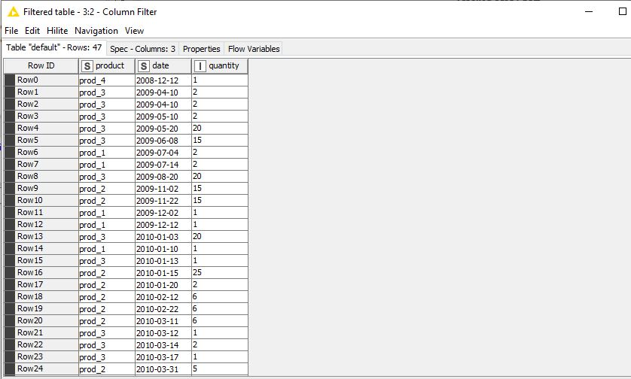

**After row filter on prod_4:**

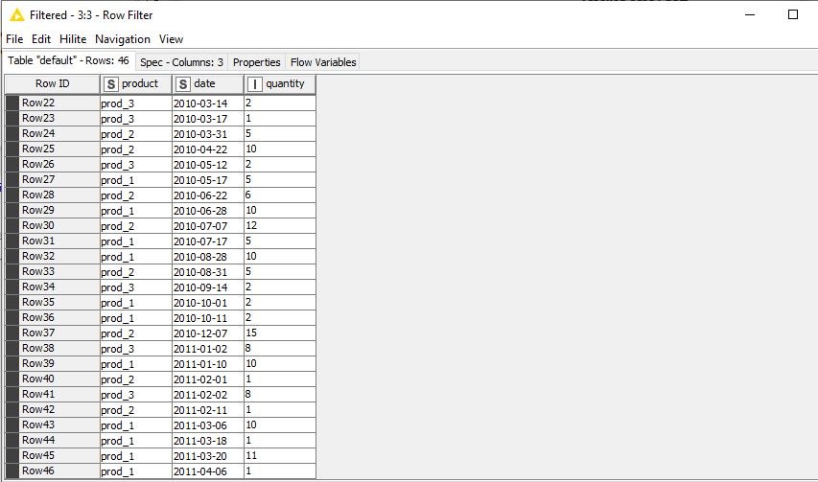**Bar chart of product vs quantity:**

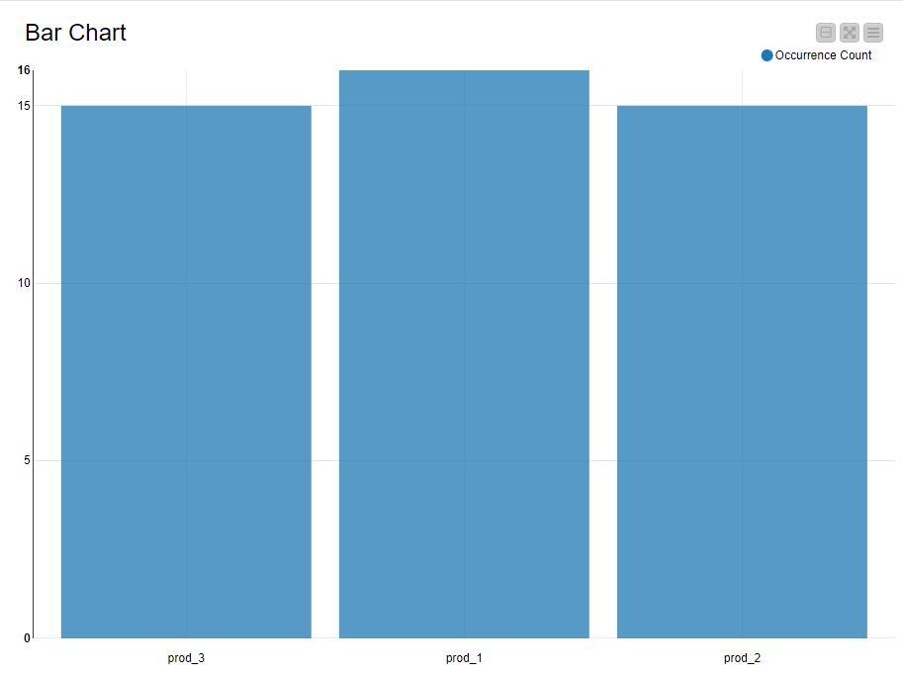

**Sunburst chart product vs date:**

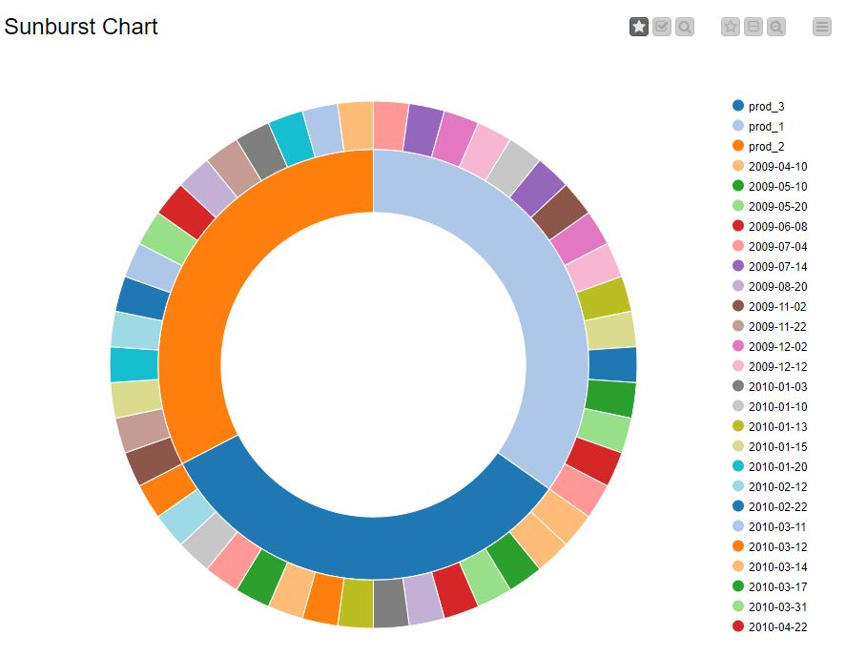**Pie chart for products:**

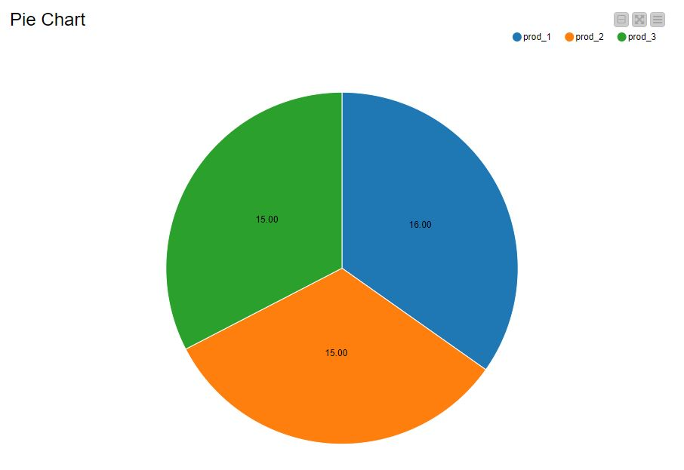

**Stacked chart date vs quantity:**

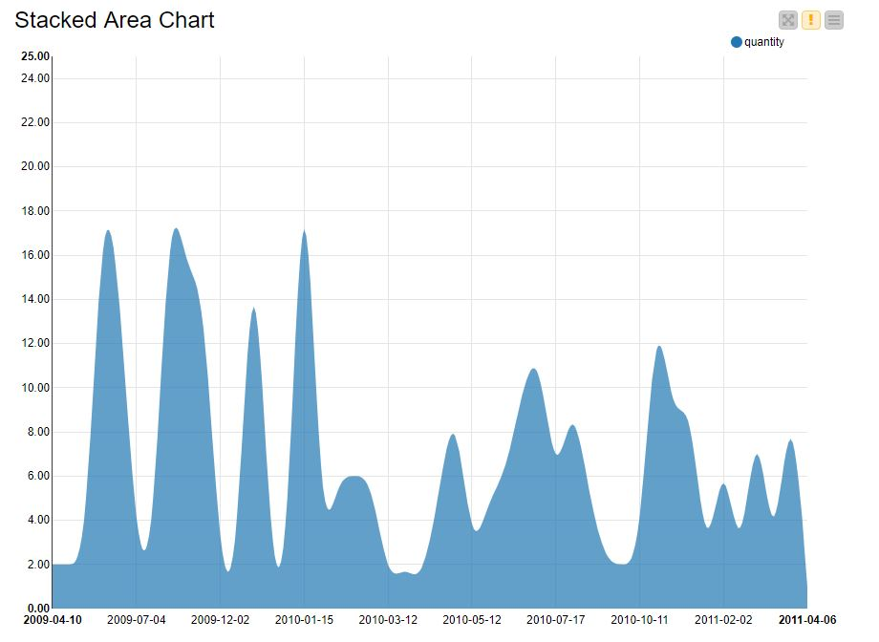**Bar chart country vs amount:**

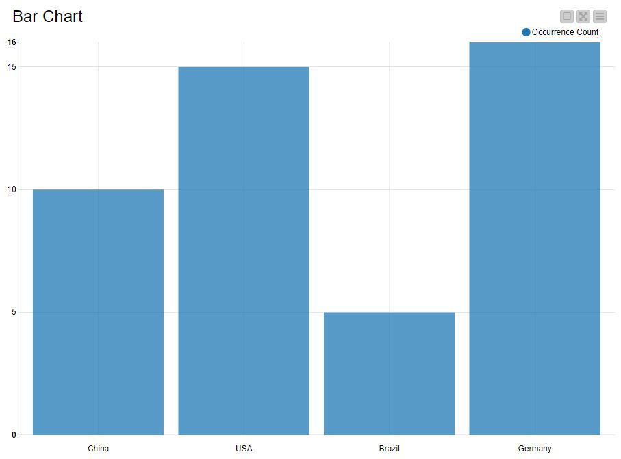

**Sunburst chart country vs date**

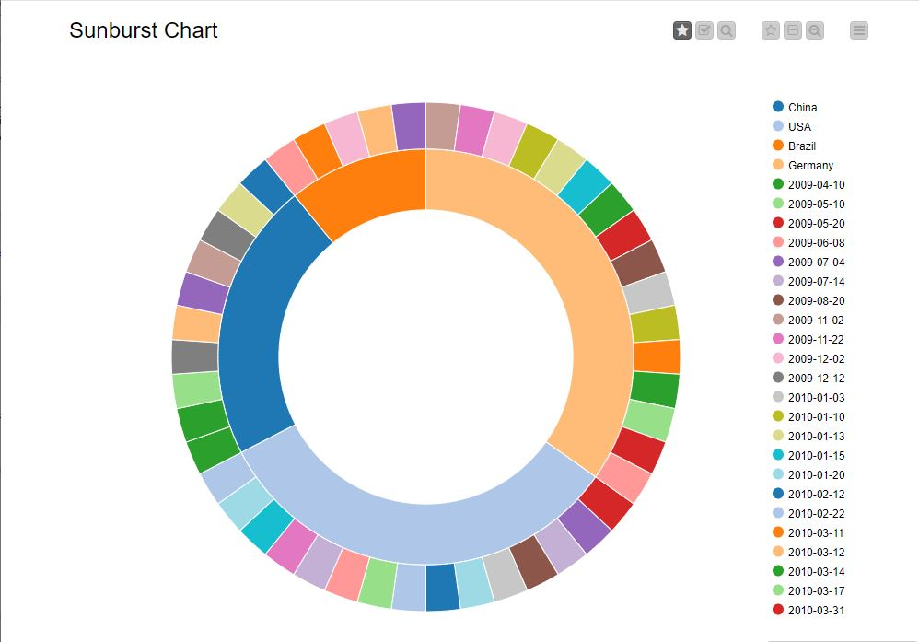**Pie chart of countries:**

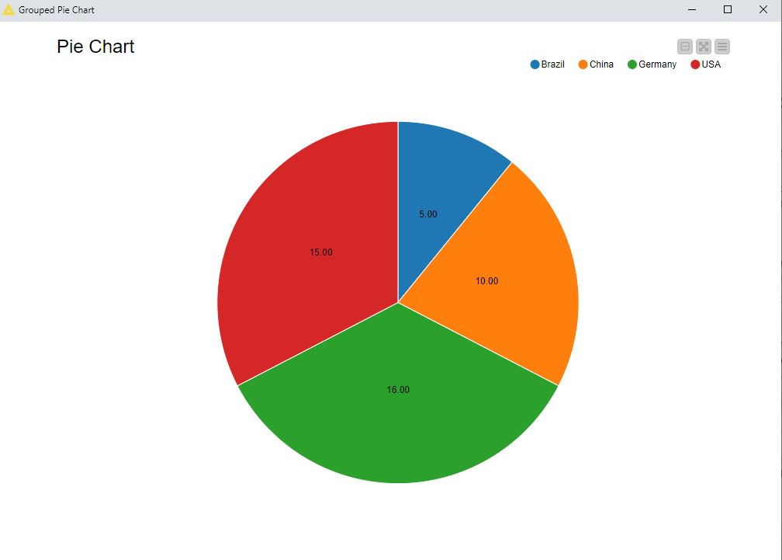

**Stacked chart amount vs date:**

